**CHAPTER-7 Class Room Objective**

**SPOTTING OUT THE EMBEDDED FIGURE**

**Embedded Figure:** A figure (X) is said to be embedded in a figure (Y), if figure (Y) contains figure (x) as its part.

**TYPE-1**

In such type of problems, a fig.(X) is given, followed by four complex figure in such a way that fig.(X) is embedded in one and only one of them. The candidate has to select such figure in which fig.(X) is embedded.

**Direction: In each of the following questions, fig.(X) is embedded in any one of the four alternative figures (a), (b), (c) or (d). Fond the alternative which contains fig.(X) as its part.**

**Ex1.**

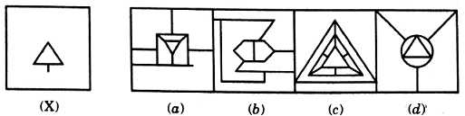

**Ex2.**

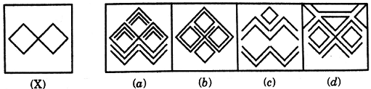

**Ex3.**

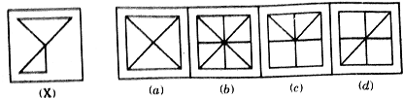

**TYPE-2**

In such type of problems, a complex figure is given, followed by four alternative figures. The candidate is required to select that alternative figure which is embedded in fig. (X).

**Ex1.**

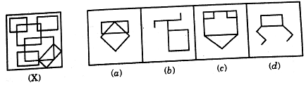

|  |
| --- |
| **EXCERCISE** |

**Q1.**

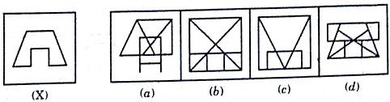

**Q2.**

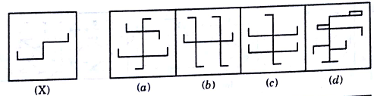

**Q3.**

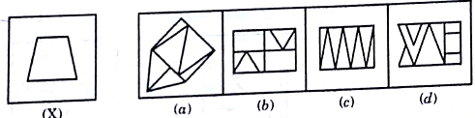

**Q4.**

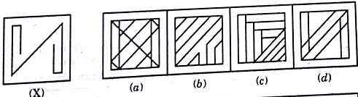

**Q5**.

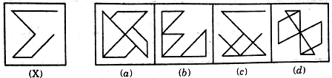

**Q6**.

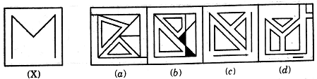

**Q7.**

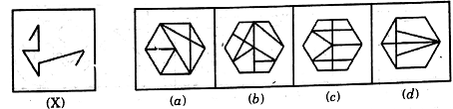

**Q8.**

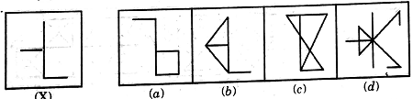

**Q9**.

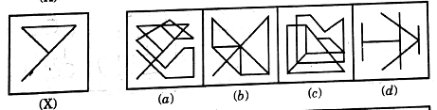

**Q10.**

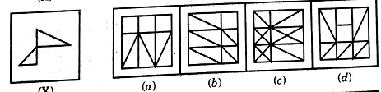

**Q11.**

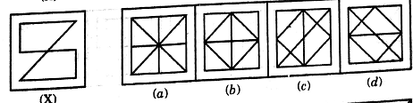

**Q12**.

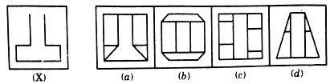

**Q13**.

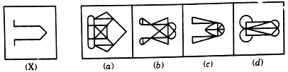

**Q14.**

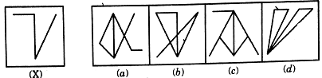

**Q15.**

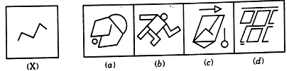

**Q16.**

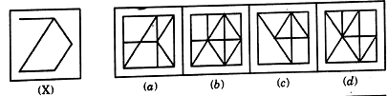

**Q17.**

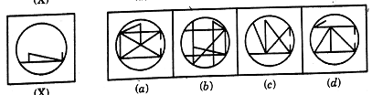

**Q18.**

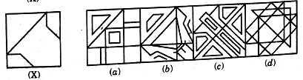

**Q19.**

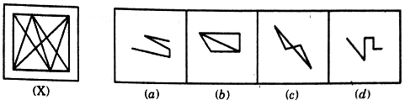

**Q20.**

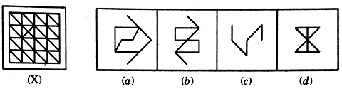

**Q21**.

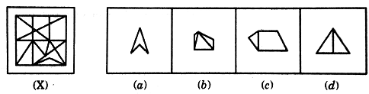

**Q22.**

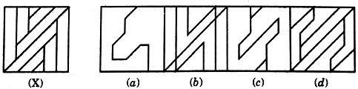

**Q23.**

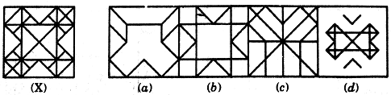

**Q24.**

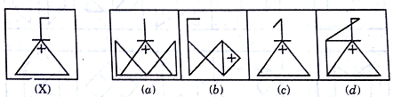

**Q25.**



